HANLEY ELIM CHURCH
WEDNESDAY WALKS

KEEPING FIT AND KEEPING COMPANY

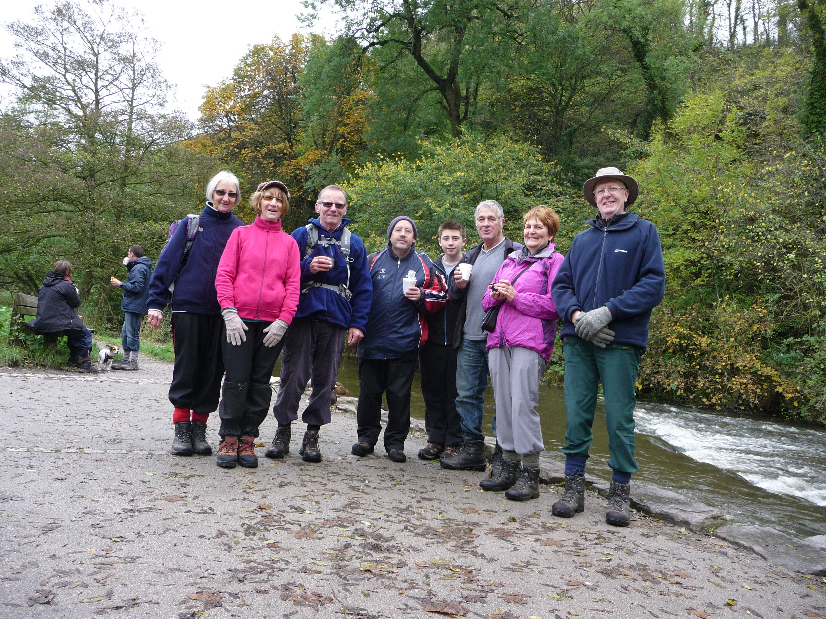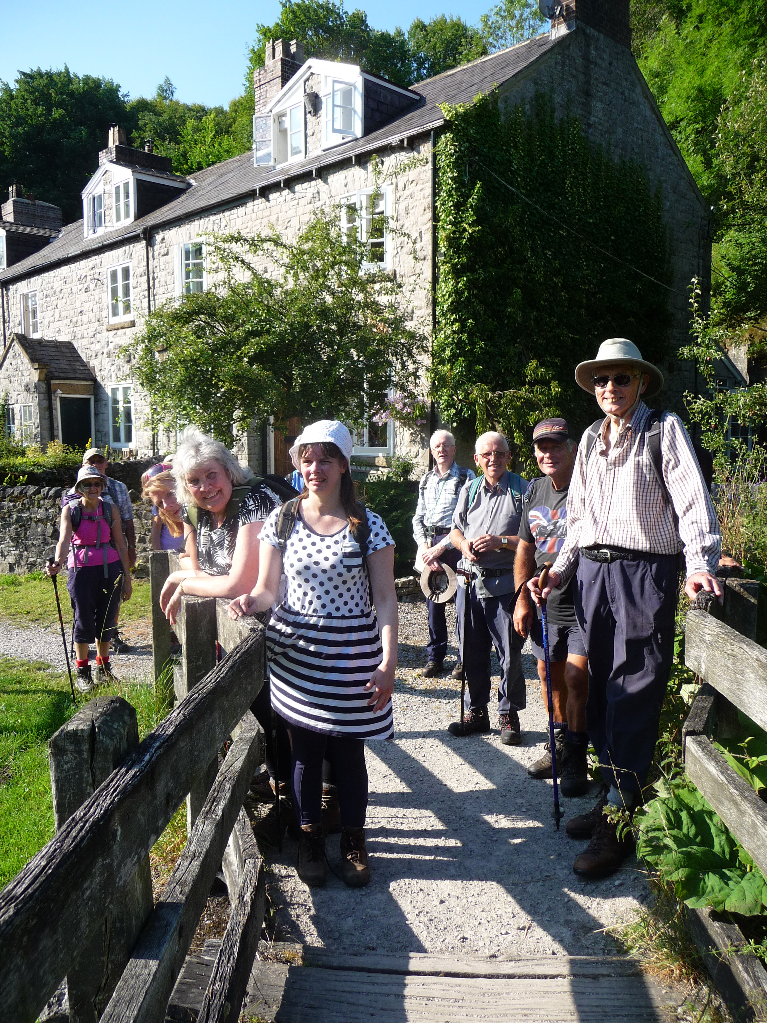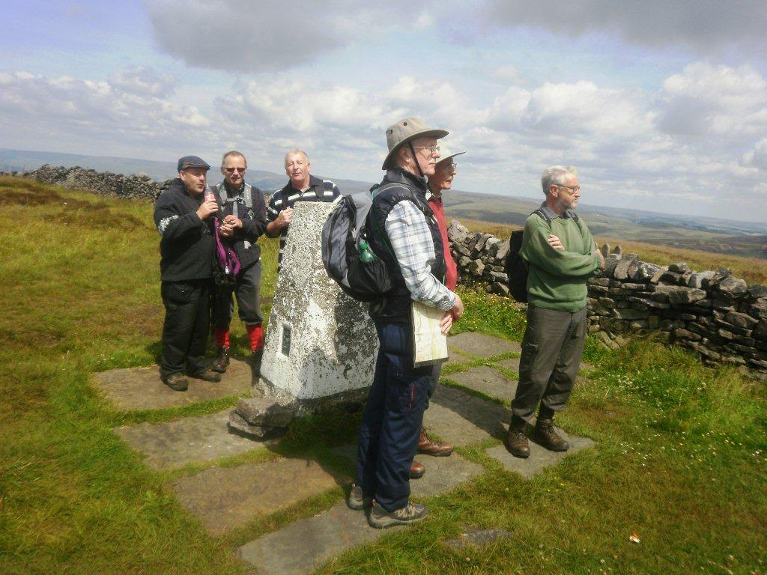

Are you interested in keeping fit and walking with a group? If so, why not join one of our monthly walks?
We meet at the church and share transport, and our walks of between 5 - 7 miles usually end with refreshments at a suitable venue close to the finish.

Walks for men - usually held on the second Wednesday of each month.

Walks for all - usually held on the last Wednesday of each month.

Do come and join us – ask at the stand to be introduced to one of the walk leaders.

Hanley Elim Church, Bucknall Old Rd, Hanley ST1 2AF
Tel. no. 01782 279092 www.hanleyelim.co.uk

